PROMISE & PRACTICE · DEEP DIVE · SOURCE ANALYSIS
The Camera Goes to War — A House Divided
What the Camera Could — and Couldn't — Show
Name: ______________________________ Period: _____ Date: ________________
WHAT I CAN DO TODAY I can read primary sources about The Camera Goes to War — A House Divided, weigh who made each one and why, and use evidence to answer historical questions.
Directions. A photograph is evidence, not magic. Judge what the technology could capture, and how its makers' choices shaped the record

THE SOURCES
SOURCE A · A STEREOGRAPH SOLD TO THE PUBLIC — A battlefield in the parlor
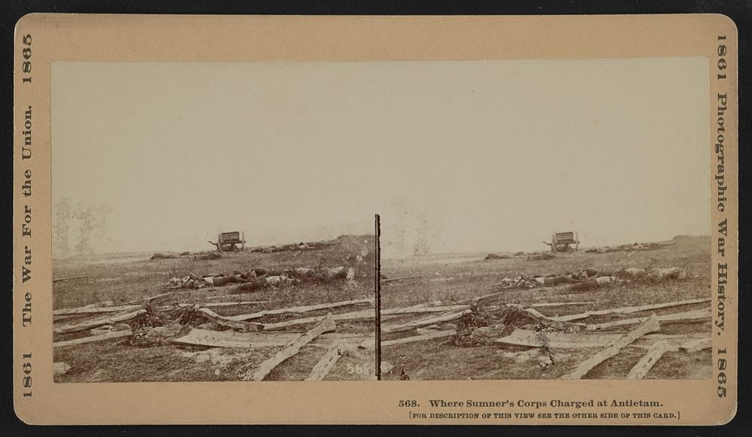
“Where Sumner's Corps Charged at Antietam” — stereograph, “The War for the Union, 1861–1865,” public domain (Library of Congress).
SOURCE B · AN AFTERMATH PHOTOGRAPH — What the camera actually recorded
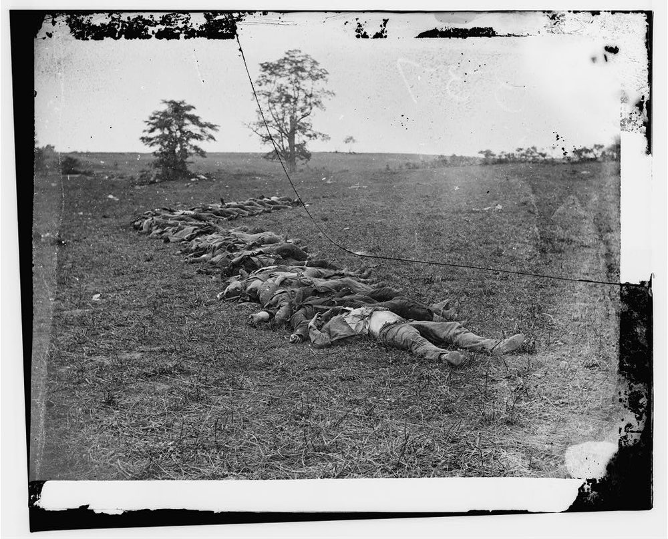
Still, silent, after the fighting — because a camera in 1862 could not freeze motion
Confederate dead in a row near the Dunker Church, Antietam — photograph by Alexander Gardner, September 1862, public domain (Library of Congress).
SOURCE C · OLIVER WENDELL HOLMES · 1863 — What viewers felt
“Let him who wishes to know what war is look at this series of illustrations. … It was so nearly like visiting the battlefield to look over these views, that all the emotions excited by the actual sight … came back to us.”
— Oliver Wendell Holmes, The Atlantic Monthly, 1863. Public domain
— Oliver Wendell Holmes, The Atlantic Monthly, 1863. Public domain.
SOURCE D · THE ILLUSTRATED PRESS — “News from the War”
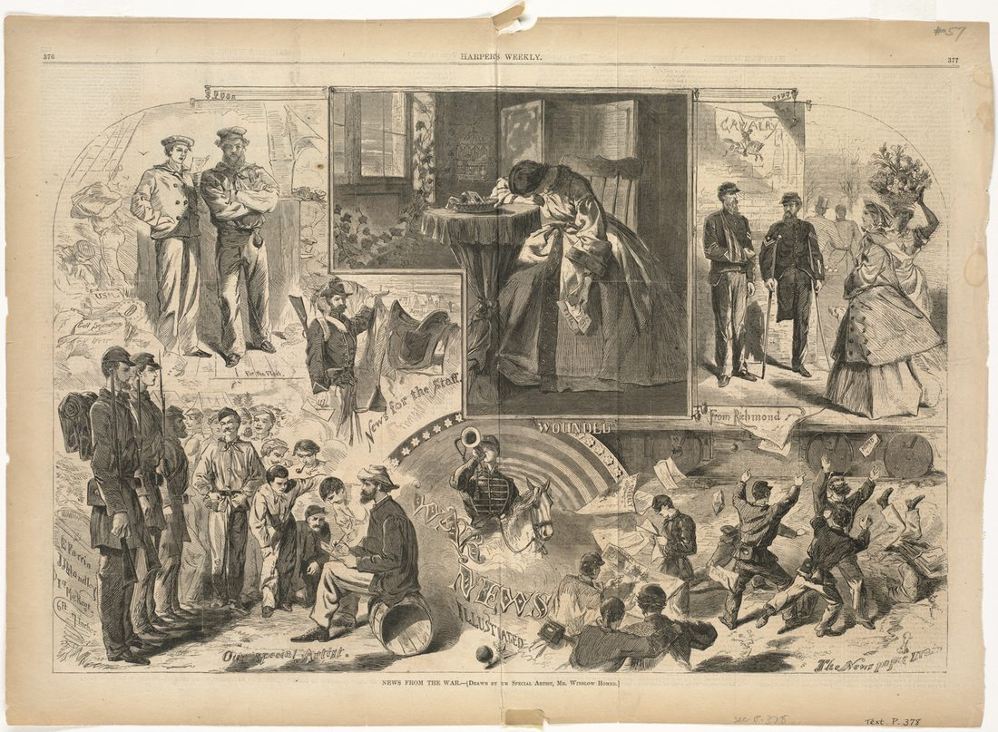
Newspapers could not yet print photographs. Instead, artists like Winslow Homer turned war scenes into wood engravings — one more layer of choices between the real event and the public
“News from the War” — wood engraving drawn by Winslow Homer, Harper’s Weekly, 1862, public domain.

YOUR WORK
QUESTION 1 STEP 1 · THE TECHNICAL LIMIT
Why are there no photographs of an actual Civil War battle in progress?
☐ A. photographers were not allowed near battles
☐ B. no one wanted to see battles
☐ C. cameras needed long exposures, so any motion blurred — only still scenes could be captured
☐ D. all the battle photos were lost
QUESTION 2 STEP 2 · WHAT THE RECORD LEAVES OUT
If every Civil War photo shows the aftermath or a posed scene — never the fighting itself — how might that shape the way later generations imagine the war? What's missing from the photographic record?
____________________________________________________________________________________________
____________________________________________________________________________________________
____________________________________________________________________________________________
____________________________________________________________________________________________
QUESTION 3 STEP 3 · RELIABILITY
Photographers chose their shots, sold them for profit, and sometimes arranged scenes. Does that make the photographs unreliable? Explain what questions a historian should ask before trusting a war photograph — and what it can still prove.
____________________________________________________________________________________________
____________________________________________________________________________________________
____________________________________________________________________________________________
____________________________________________________________________________________________
QUESTION 4 STEP 4 · WHY IT MATTERS
Using Holmes (Source C), explain why being able to see the war — even only its aftermath — changed how Americans experienced it. Why does it matter that the Civil War was the first war a nation could view this way?
____________________________________________________________________________________________
____________________________________________________________________________________________
____________________________________________________________________________________________
____________________________________________________________________________________________
Promise & Practice · ShadowDog Digital Studios · Unit 2

TEACHER ANSWER KEY — The Camera Goes to War — A House Divided

QUESTION 1: Correct — C. cameras needed long exposures, so any motion blurred — only still scenes could be captured
Right. Long exposure times meant anything moving blurred, so cameras could only capture still scenes — the aftermath or posed shots. The technology decided what could be recorded.
QUESTION 2: Open response.
Look for a response along the lines of: “Because photos only show…, our image of the war tends to…. What's missing is…”
QUESTION 3: Open response.
Look for a response along the lines of: “A historian should ask… The photos can still prove… but we must be careful about…”
QUESTION 4: Open response.
Look for a response along the lines of: “Seeing the war mattered because…”

